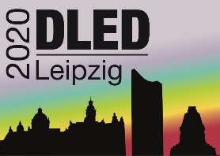
Registration
German Luminescence and ESR Dating Meeting
27 – 29 November 2020
Leipzig, Germany

The registration period is open until 31 October 2020. Please complete the registration form and send it to DLED2020@eva.mpg.de
First name Click or tap here to enter text.
Family name Click or tap here to enter text.
Email Click or tap here to enter text.
Institution Click or tap here to enter text.

There is no registration fee as the cost of hosting the meeting will be covered by the Department of Human Evolution, Max Planck Institute for Evolutionary Anthropology.
The number of places at the meeting is limited to 60 people. Places will be allocated on a first-come first-serve basis and receipt of registration forms will be confirmed via email.

☐ Please check the box if you are a student (e.g. MA/BA) or PhD candidate and would like your presentation to be considered for the presentation prize.

I would like to register a talk / poster (delete whichever is not applicable) with the following title:
Click or tap here to enter text.
Short abstract (max. 50 word)
Click or tap here to enter text.

